# 3

# Interdisciplinary Teaching and Learning — *or* — Two Heads Might Actually Be Better Than One

## Yesterday and Today

In this interconnected, socially networked, 24/7, multidimensional, media-centric culture, your students are doing just fine creating, performing, and making things without your help.  Thanks to the proliferation of user-friendly, intuitive software applications to create, capture, and perform music, and websites that allow easy showing and sharing of these creations, your students can lead very productive, creative, and expressive lives without the baggage of learning traditional music notation and computer code.  This realization sends shudders through some of our fellow professors, but nonetheless it is a reality of our times.  You can choose to fight these trends and hold fast to the traditions of an educational system designed for another era and different priorities, or you can meet the students where they are.

Much of education has been about the transmission of subject-specific content with a focus on the individual. This fosters competition for the teacher’s attention and top grades. Hierarchical classrooms perpetuate the notion of teachers as authority figures and decision makers while supplicant students wait for the teacher’s knowledge to be bestowed upon them.  Socialization is rarely encouraged inside the classroom. On the other hand, the modern workplace is flattening its hierarchical structure and becoming ever more dependent upon critical thinking skills, collaboration, teamwork, and shared decision-making.  In fact, many corporate offices are physically being designed to foster collaboration through shared offices and informal small lounges where workers can gather to brainstorm [4]. Learning to work with others is a life-long endeavor. These skill sets don’t develop in a vacuum.  They need to be nurtured through modeling and experience.  As suggested by John-Steiner [6], students need to be socialized into the culture of collaborative work and the kinds of creative and critical thinking the new workplace requires.

As you will discover, collaborative work yields processes and results that are far richer than any that a single person’s expertise can produce. John-Steiner calls this “creative collaboration”: “In collaborative work we learn from each other by teaching what we know; we engage in mutual appropriation. Solo practices are insufficient to meet the challenges and the new complexities of classrooms, parenting, and the changing workplace” [op. cit., p. 3]. We found out however, both by observing the students in their project teams and reflecting on our own interactions as teachers, that collaborative work creates a complex dynamic where diverse ideas and opinions are continually being challenged and negotiation is a constant presence.  It quickly became clear that creating interdisciplinary assignments and forming multidisciplinary student teams to share the work is not enough. Getting team members to actually learn new skills from their peers in other disciplines simply would not happen without a great deal of mediation and guidance from us, the teachers.

## Defining Interdisciplinary Teaching

So what exactly do we mean when we say that a course is “interdisciplinary”? There are many definitions and variations, some involving one teacher presenting multiple perspectives and others involving team teaching.

Interdisciplinarity is often described as “the integration of disciplinary perspectives” [7], which in our case would be music and computer science. It is often confused with “multidisciplinary,” which Spelt et al. [12] describe as “additive,” presenting multiple perspectives without the integration of the disciplines or opportunities for students to synthesize knowledge from them.  Davis [2] points to the need for “blurring genres” and “synthesizing disparate sources into new knowledge.” He claims that the disciplinary focus of much of higher education cannot adequately address the issues confronting 21st century thinking.  Davis is an advocate for faculty to work in teams, believing that teams can achieve what individual disciplinary specialists cannot.

We embrace Davis’s last point wholeheartedly. To us, it takes two to tango. We feel that the only way to give students a truly interdisciplinary experience is to have a professor from each discipline present at all class meetings. We understand the logistical problems that this presents, and we address those in a later chapter. We also understand the differences of opinion and perspective that will arise in class, but we see no need to hide those from students. As the comment shown in Figure - makes clear, we do not shy away from our differences, we embrace them.

|  |
| --- |
| DontFight-Merged.gif |
| *Figure 2-1*. A student comment  on our teaching. |

We fought?!?  Wow. We didn’t think we fought. But that’s how this student characterized some of our interactions on an end-of-semester Course Evaluation form. We may still have a lot to learn about how to get our different perspectives across without appearing to “fight,” but teaching an interdisciplinary course is and always will be a work in progress that is full of unexpected surprises. In addition, rather than trying to homogenize our perspectives of each others’ fields, we find that those differences foster a creative and fruitful environment that stimulates not only student learning, but ours as well.

When those differences result in squabbles, we believe that everyone in the room — including the teachers — learns from the resolution of those differences. It almost goes without saying that throughout this work Gena has learned a lot about computing from Jesse, while she in turn has taught him to think more deeply about the sounds he hears and even the horizons of what he considers to be “music.” The dual perspective of our collaboration, and our attempt to share both perspectives with students, is therefore the essence of what we define as interdisciplinary teaching.

## “Synchronized” vs. “Hybrid” Courses

One of the first decisions you will need to make is whether or not to take the plunge into interdisciplinary teaching, either by revising and rethinking an entire course or by beginning with a small well-defined project. Our first foray was project-based and probably closer to the “additive” multidisciplinary approach. We put students together from regular classes that we were already teaching, *General Music Methods* and *GUI Programming.* (“GUI” stands for “Graphical User Interface”.)  Our colleague Fred Martin dubbed these “synchronized” courses [8].  Students did a project that we will describe later in detail, but suffice it to say at this point that the students in each course did their parts of the project independently. They then came together a few times during the semester to share, discuss, and evaluate their work as shown in Figures - and -.

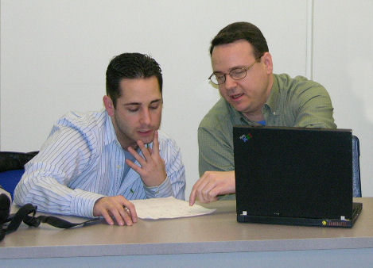

*Figure 2-2.* A CS and Music student working together on the design  
of a music composition program in a synchronized course.



*Figure 2-3.* Usability test by an interdisciplinary Music + CS team.

The synchronized courses showed some positive results, but we wanted more.  We wanted students from different disciplines to work together throughout an entire semester.  We therefore developed what Martin [*op cit.*] termed a “hybrid” course, co‑taught with both of us in the classroom simultaneously.  This is *Sound Thinking*, focusing on the study of sound from the perspective of digital musicianship.

Like Don Marinelli and Randy Pausch at Carnegie-Mellon University [11], Gena and Jesse “personified the mix of arts and technology; right brain/left brain, [music gal]/computer guy” [p. 124].  In Pausch’s book *The Last Lecture* [*op cit.,* p. 125], we could easily substitute our own names for Don’s and Randy’s: “Given how different Don and I were, at times we became each other’s brick walls.  But we always managed to find a way to make things work.  The result was that students often got the best of our divergent approaches (and they certainly got role models on how to work with people different from themselves).”  As discussed earlier, we didn’t try to hide our differences and differing perspectives, which led that one student to think we were “fighting” when we let our bantering go a bit too far.  We will talk about ways to address this issue in a subsequent chapter.

## Learning from Experience

As you begin to develop your interdisciplinary experience, be mindful of setting up regular meeting times before and during the semester for planning, reflecting, and modifying some of the course details. Strong communication and the ability to evaluate one’s work “in process” are essential to a successful collaboration. You and your colleague should attempt to make a conscious effort to find a common class meeting time and try to set aside specific days when the classes will meet as one. As we both learned from previous attempts at this, it’s a good idea to introduce the project together and build it in phases. You may also wish to think about setting up multiple planning meetings before the beginning of the semester as well as scheduling regular meetings throughout the semester to evaluate, reflect upon, and make modifications to the project as needed.

The following comment, from one of the Music Education students, pretty well sums up the class sentiment when they were informed that we would be working on an interdisciplin­ary project with a group of computer science students.

We were introduced to the computer science majors from Jesse’s class this week. I think that the class had mixed emotions about this. A lot of people were wary because of the project that we did in tech class...

Many of these Music Ed students had participated in a previous interdisciplinary project. They therefore initially greeted the prospect of this project with a great deal of apprehension. One student wrote in her journal:

The first thing I thought when I saw the computer science students: Oh, great. Another team of people [who] will never get back to us and make our grades suffer.

A subsequent journal entry by this same student showed a significant change of heart:

The computer science students know how to read symbols and try to put a meaning to them quicker than most. I enjoy having them come and participate in our classroom activities.

The Music Ed students were quickly won over by the fact that we had arranged for so much in-class contact with the CS students, which resulted in substantial bonding between students who would normally never come into contact with each other.

You may also wish to consider building in time for the students to evaluate each other’s work. Peer to peer feedback is invaluable to the learning process, particularly so with a diverse group of students with different strengths. As previously suggested with regard to the definition of computational thinking we sometimes get hampered by our habits of mind and modes of thinking. Getting students to think about solutions from another person’s perspective will help in developing their analytical thinking skills, one of the benefits of a computational thinking mindset. In our case, when the teams were required to present their work, we did it as one class. This made it possible for CS students to comment on the work of and give feedback to the music students, and vice-versa.  In addition, the students developed an appreciation for the differences in thinking and learning styles and the creative thinking that formed a common link between them. This was confirmed by comments in another student’s journal:

… I feel that this time we have more support from the professors involved and that the CS students are more into the idea.  I like how the project has benefits for both sides.  It allows us to be able to think back to the beginnings of notation and to communicate our ideas with little to no explanation to people who have no musical background.  For the CS students, they get a taste of what it is like to work for a client and to interact with people to give them a final product that is efficient.

What resulted was a successful collaboration all around, based on what, for the most part, fits the definition of an interdisciplinary project.  The general sentiment of the Music Ed class with regard to this new collaboration, was summed up by one student:

Boy, do I really like to have the CS students in our class!  I feel we are really becoming one class, not just two classes in the same room.  It’s great to have other voices in the class, and to provide perspective from students outside the music department.

“Not just two classes in the same room.” What better confirmation could we have asked for? We were pumped, but could we do it again and make it last an entire semester?

Building an entire interdisciplinary course around a long-range project or thematic idea can be a daunting task without a clear idea of your purpose for doing this in the first place. In the case of our own class*,* our goal was to create an entire interdisciplinary course for all students interested in music technology and how to manipulate it. Or, more to the point, to use a metaphor often used by Jesse, we were going to have students “get under the hood” to discover how these programs work.  We therefore based our strategies and projects on the interdisciplinary synchronized course module we created for computer science and music majors.

Whether you are attempting a single interdisciplinary project or developing an entire course, you may want to use the following questions as a guide to frame your thinking and planning:

1. What is it that you hope to gain with regard to your students’ learning?
2. How will this impact your own personal and professional growth?
3. What will the overall benefits be? What barriers will you have to overcome?
4. What are the compromises you will have to make when you enter into a long-term collaborative endeavor?
5. And, most importantly, how exactly are you defining interdisciplinarity with regard to your content and teaching?

In our case, our rationales for developing the new course were straightforward.  For Music Education majors, there are few opportunities to gain immersion into areas of study outside their discipline, let alone the technologies that may support and enhance their work.  Even students in our Sound Recording Technology program sometimes lack sufficient opportunities to understand the programming and visual aspects of multimedia technology that support much of their work.  At the other end of the spectrum, those who design and build software applications have few opportunities to pursue in-depth study of multimedia applications from the perspectives of the audio and visual artists who are their end users.

Whatever your rationale, one of your goals should be to break down boundaries created by compartmentalized instruction and have your students see their own work through an interdisciplinary lens. You will find that such experience is critical in preparing students for the multidisciplinary workplace, regardless of their major field. In particular, you will find it is critical to students interested in working with and understanding digital media from the perspective of creating with sound.

## Benefits to Students

Boix Mansilla and Gardner [1] believe that merely teaching subject matter does not draw upon or challenge students’ intuitive understandings of the world.  They suggest that every discipline has its own ways of thinking about the world and communicating its ideas. In their view, “students develop a disciplined mind when they learn to communicate with the symbol systems and genres of a discipline” [*op cit.*, p. 104]. In our case, that might start with musical notation or computer code. However, as one becomes immersed in a discipline, one quickly realizes the limitations of such symbol systems.  After a rather detailed demonstration of the value and limitations of both traditional musical notation and more inventive graphic notation, one student commented:

One of the things we’ve often debated in class is the issue of freedom [and] artistic limitations [imposed by] the method of sound production and notation. In other words, what things inhibit our ability to perform and create naturally, or what things stop us from thinking “outside the box”?

We set out to explore broad concepts through the lenses of our respective disciplines and integrate those concepts within a project-based learning environment. We put students into the position of decision makers, a role they do not often occupy [3].  Boix Mansilla and Gardner suggest that such projects give students multiple opportunities to develop “performances of understanding,” in which students are invited “to think with knowledge in multiple novel situations” [*op cit.*, p. 105]. They discuss at length the importance of training students to think like the practitioners in the various fields of study they encounter during their schooling.

So what does this mean for your students and why is it that you should care? In our case, one of our goals was to give students “real-world” experiences. Perhaps the fact that we both began our careers in the world of business might have something to do with shaping our perspectives on the skills and thinking that our students will need once they leave our classrooms.

Among the many advantages of interdisciplinary courses is that these courses encourage and support creative risk taking and the ability to accept ambiguity [10]. This would seem to benefit professors, as well as students.

## Benefits to the Professors

The benefits to you as teachers can be profound as well. Joint classes with a faculty member in another discipline can present significant learning experiences, breaking down the isolation that faculty sometimes feel within one’s own department or discipline. Course planning conversations and project meetings are opportunities for reflective practice allowing you to explore ideas about pedagogy and the skills necessary for students to be truly well-educated. The ability to revisit what you teach and how you teach with a new perspective has the potential for professional revitalization in a manner that typical professional development workshops may not always accomplish.

*A River Runs Through It* is not only the title of a movie, but also a very real description of the physical and ideological divide that separates the left and right brain thinkers of our campus. Our university is divided by the Merrimack River, with our North Campus housing the Math, Science, and Engineering departments on one side and our South Campus housing the Arts, Humanities, and Social Sciences on the other (see Figure -). While there are many opportunities for *faculty* within a single department or college to interact in terms of committees, dinners, and research symposia, the demands of scheduling blocks, the differences in each major’s curriculum requirements, and the variations in each department’s promotion and tenure requirements make it far more difficult for science and arts colleagues to interact in any kind of meaningful way.

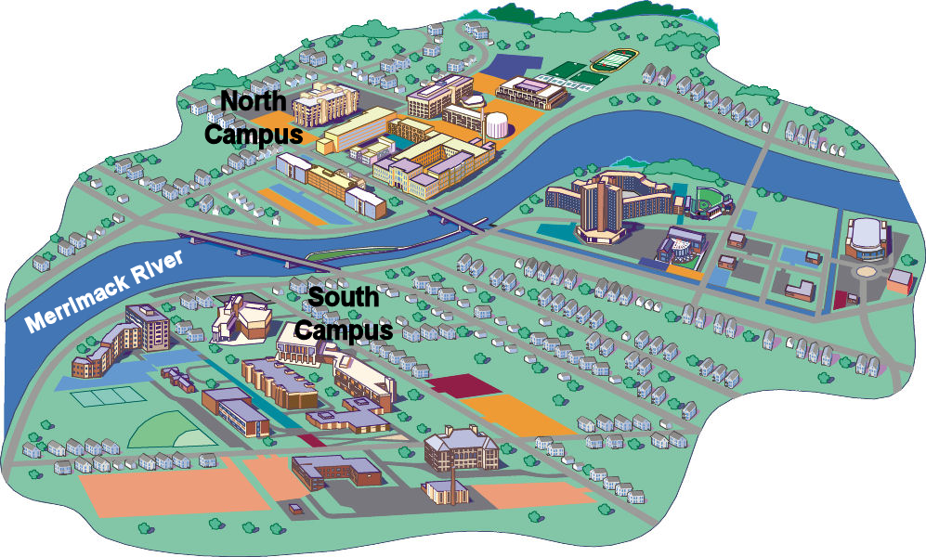

*Figure 2-4.* “A river runs through ...” our university.

In the world of interdisciplinarity, we, Gena and Jesse, would be known as “early adopters,” at least at our university. We began collaborating several years before our *Performamatics* project was funded by the National Science Foundation and before interdisciplinary endeavors were “the thing to do” on our campus [5].  Our paths crossed through a university-wide grant opportunity in which we developed an online practice test for the music teacher certification exam. Early in that project we discovered that even though we approached issues from differing perspectives, talking through our ideas and differences of opinion often led us to end results neither of us anticipated at the outset.

Here are some of the benefits we experienced. We are fairly certain that others can experience this, as well:

* You will each learn a lot more about each other’s discipline.
* You can attend and present your work at conferences in each other’s field, further expanding your respective knowledge of each other’s disciplines.
* You will most likely receive significant recognition within your own university, raising your profiles. In our case we were each invited to serve on university-level committees that may influence the future of interdisciplinary teaching at our institution.
* You will be introduced to other colleagues in your respective departments, thereby expanding the scope of your work, leading to new collaborations and possibly to grant applications.

On top of all that, if our experiences are any indication, you will quite simply have a lot of fun. This last point should not be taken lightly. The National Science Foundation program that funded our own work was conceived to “revitalize undergraduate education in computing” [9]. As we strove to achieve that goal, we found that the process revitalized us as educators. Such faculty revitalization is clearly key to educational transformation, because while faculty are not always the major source of curriculum *innovation,* they are—and for the foreseeable future will remain—the major component of curriculum *implementation*.

## Bibliography for Chapter 1

[1] Boix Mansilla, V., & Gardner, H. (2009). *Disciplining the Mind*. In M. Scherer, ed. (2009). *Challenging the Whole Child: Reflections on Best Practices in Learning*. ASCD: Alexandria, VA. p. 97-106.

[2] Davis, J.R. (1995). *Reengineering Teaching for 21st Century Learning.* The Educational Record **76**(4):16-23.

[3] Greher, G.R. (2006). *Transforming Music Teacher preparation through the Lens of Video Technology.* Jrnl. of Music Teacher Ed. **15**(2):49-60.

[4] Halbersgerg, E. (2012). *TPG Architecutre helps global PR firm Weber Shandwick make the move to a more collaborative mindset in its new Chicago offices*. *Interiors Sources Magazine*. May 2012 **28**(5):96-101.

[5] Heines, J.M., Martin, F., Roehr, K., Jeffers, J., Greher, G.R., & Strukus, W. (2007). *CPATH CB: Performamatics: Connecting Computer Science to the Performing, Fine, and Design Arts*. <http://www.nsf.gov/awardsearch/showAward.do?AwardNumber=> 0722161 *accessed* 4/19/2010.

[6] John-Steiner, V. (2000). *Creative Collaboration*. New York: Oxford Univ. Press.

[7] Lattuca, L.R., Voigt, L.J., & Fath, K.Q. (2004). *Does Interdisciplinarity Promote Learning? Theoretical Support and Researchable Questions.* The Review of Higher Education **28**(1):23-48.

[8] Martin, F., Greher, G.R., Heines, J.M., Jeffers, J., Kim, H.-J., Kuhn, S., Roehr, K., Selleck, N., Silka, L., & Yanco, H. (2009). *Joining Computing and the Arts at a Mid-Size University.* Jrnl. of Computing Sciences in Colleges **24**(6):87-94.

[9] National Science Foundation (2010). *CISE Pathways to Revitalized Undergraduate Computing Education (CPATH)*. <http://www.nsf.gov/funding/pgm_summ.jsp?pims_id=500025> *accessed* 4/19/2010.

[10] Nikitina, S. (2005). *Pathways of Interdisciplinary Cognition.* Cognition and Instruction **23**(3):389-425

[11] Pausch, R., & Zaslow, J. (2008). *The Last Lecture*. New York: Hyperion.

[12] Spelt, E.J.H., Biemans, H.J.A., Tobi, H., Luning, P.A., & Mulder, M. (2009). *Teaching and Learning in Interdisciplinary Higher Education: A Systematic Review.* Educational Psychology Review **21**:365-378.